Name & Std No.: Riley Lawson 116555487 Lab Section: 6

Date: 11/5/2020

**Submission Instructions:**

**Prelab:**

1. **Complete the prelab**
2. **Submit this report with the prelab completed to Canvas before your lab starts**

**Lab:**

1. **Complete the lab according to the instructions**
2. **Take screenshots of your ModelSim waveform (note: to receive points your NetID has to be present in the screenshot) and insert them into this document.**
3. **Include screenshots of any related block design files or Verilog files in the report**
4. **Complete this report and reupload it to Canvas**

**PRELAB:**

### *Refer to Chapter 5 in your textbook and the lab instructions to complete your pre-lab. Please read all the material and complete the circuit diagrams before you come to the lab.*

**Q1.** Draw the circuit diagram for the 4-bit **Shift Register** using D flip-flops in the space below.

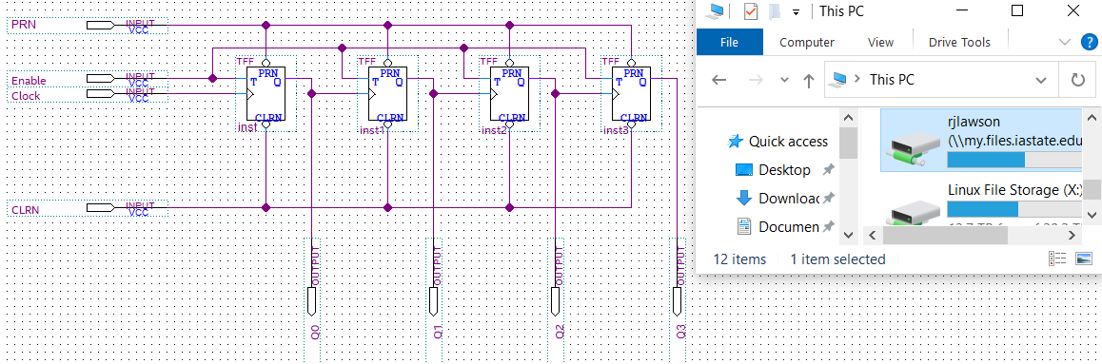

**Q2.** Draw the circuit diagram for the 4-bit **Synchronous Up-Counter** using **D flip-flops** in the space below.

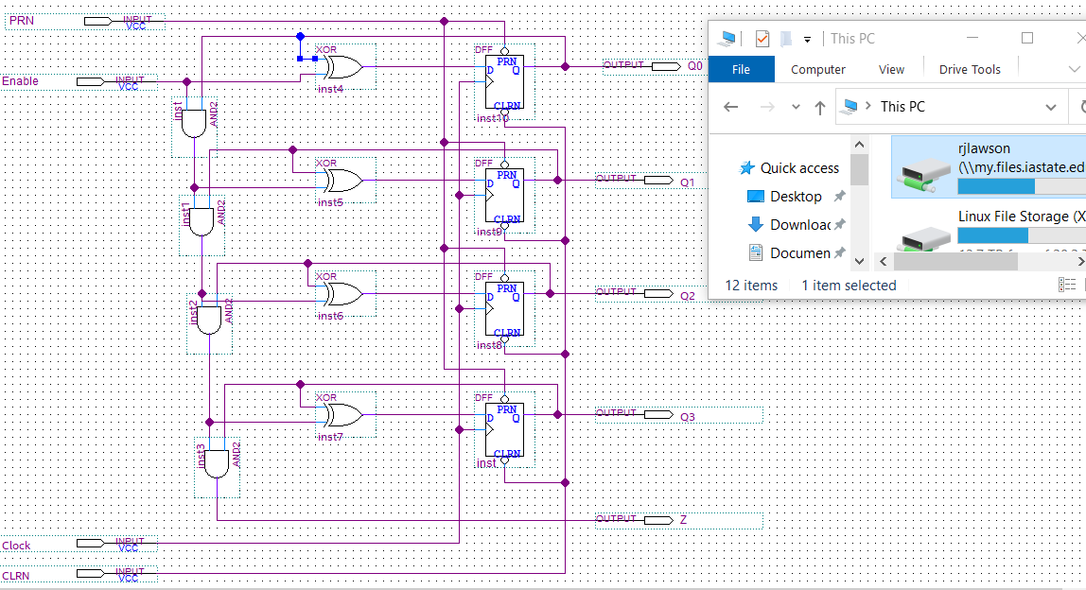

**Q3.** Draw the circuit diagram for the 4-bit **Synchronous Up-Counter** using **T flip-flops** in the space below.

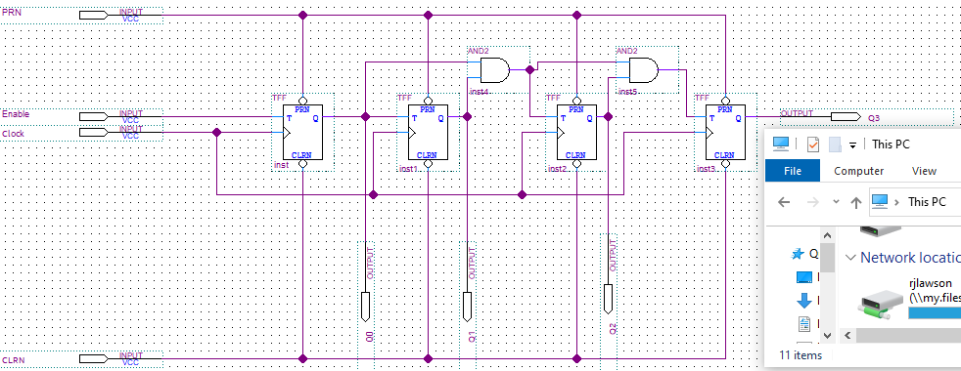

**Q4.** Draw the circuit diagram for the 4-bit **Asynchronous Up-Counter** using T flip-flops in the space below.

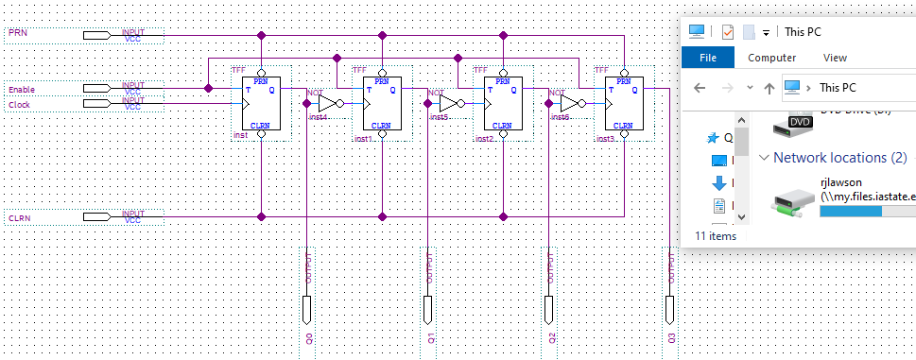

**Q5.** Draw the circuit diagram for the 4-bit **Asynchronous Down-Counter** using T flip-flops in the space below.



**LAB:**

**2.0**  Fill in the sequence table below. *Watch out for switch bouncing!*

|  |  |  |  |  |
| --- | --- | --- | --- | --- |
| ***In*** | ***Q1*** | ***Q2*** | ***Q3*** | ***Q4*** |
| t0 = 1 | ---- | ---- | ---- | ---- |
| t1 = 0 | 1 | ---- | ---- | ---- |
| t2 = 1 | 0 | 1 | ---- | ---- |
| t3 = 1 | 1 | 0 | 1 | ---- |
| t4 = 1 | 1 | 1 | 0 | 1 |
| t5 = 0 | 1 | 1 | 1 | 0 |
| t6 = 0 | 0 | 1 | 1 | 1 |
| t7 = 0 | 0 | 0 | 1 | 1 |

<<<Insert a screenshot of shift register here>>>



<<< Insert a screenshot of your waveform for shift register here>>>

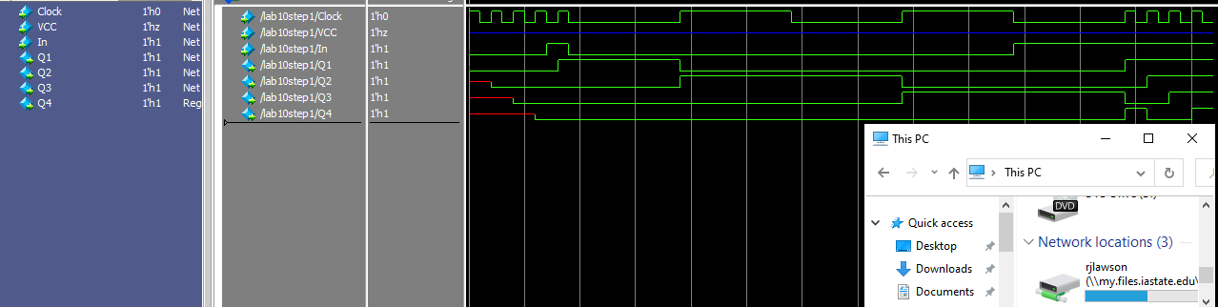

Synchronous counters:

<<<Insert a screenshot of SYNC UP counter>>>



<<< Insert a screenshot of your waveform for SYNC UP counter here>>>

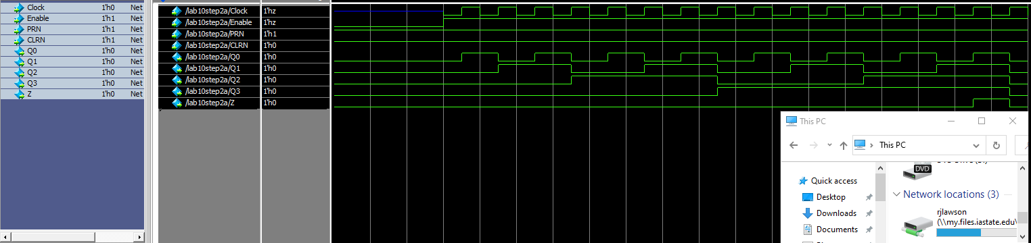

<<<Insert a screenshot of SYNC Down counter>>>



<<< Insert a screenshot of your waveform for SYNC Down counter here>>>

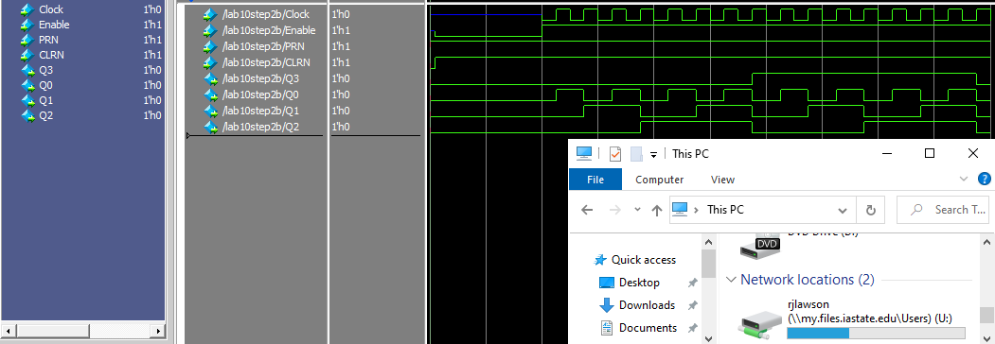

Asynchronous counters:

<<<Insert a screenshot of ASYNC UP counter>>>



<<< Insert a screenshot of your waveform for SYNC UP counter here>>>

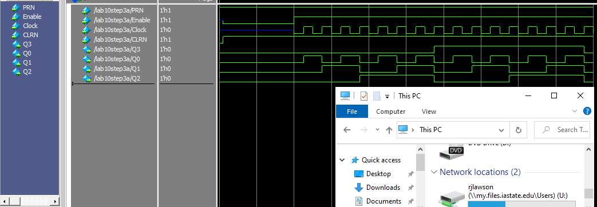

<<<Insert a screenshot of ASYNC Down counter>>>



<<< Insert a screenshot of your waveform for ASYNC Down counter here>>>

